Software Design Document

for

<Online Jewelry Shop>
Version 1.0 approved
Prepared by <Arooba>
<date created>

Revision History
Date | Description | Author | Comments
<date> | <Version 1> | <Your Name> | <First Revision>

Document Approval
The following Software Requirements Specification has been accepted and approved by the following:
Signature | Printed Name | Title | Date
 | Ms Kainat | Online Jewelry Shop | <date>

Table of Contents

1. Introduction 3
1.1 Purpose 3
1.2 Scope 3
1.3 Overview 3
1.4 Reference Material 3
1.5 Definitions and Acronyms 3
2. System Overview 4
2.1 System Use cases and Use case diagrams 4
2.1 System Activity Diagrams 4
2.2 System Sequence Diagrams 4
3. Backend Design 5
3.1 Data Description 5
3.2 Data Dictionary 5
4. Front-end / User Interface Design 6
4.1 Overview of User Interface 6
4.2 Screen Images 6
4.3 Screen Objects and Actions 6
5. System Architecture 7
5.1 Architectural Design 7
5.2 Decomposition Description 7
5.3 Design Rationale 7
6. Component Design/System Architecture 8

Introduction
Welcome to our online jewelry shop. We offer a wide range of beautiful jewelry From necklaces to earrings, we have it all Our jewelry is made with high-quality materials We have something for every style and budget Our online shop is easy to navigate and secure We offer competitive pricing and regular promotions Our customer service team is always available to help We're passionate about providing excellent customer service Shop with us today and discover your new favorite piece!

Purpose
To sell jewelry online to provide a convenient shopping experience To offer a wide range of jewelry products To make jewelry shopping accessible to everyone To provide excellent customer service To make buying jewelry easy and enjoyable To showcase new and trendy jewelry designs To provide a secure and trusted online shopping environment To offer competitive pricing and promotions To help customers find the perfect piece of jewelry.

1.2 Scope
- Geographic scope: Global, national, or regional.
- Product scope: Various types of jewelry, including fine, fashion, and custom-made pieces.
- Target audience: Individuals, businesses, and organizations seeking jewelry for personal or gift-giving purposes.
- Services: Online shopping, customer support, shipping, and returns.
- Features: Product reviews, ratings, recommendations, and wish lists.

1.3 Overview
An online jewelry shop is an e-commerce platform that sells various types of jewelry products through the internet.

Key Features

- Wide selection of jewelry products.
- Easy navigation and search functionality.
- Secure payment processing and shipping.
- Customer support and reviews.

Benefits

- Convenient shopping experience.
- Global accessibility.
- Competitive pricing.
- Wide selection of products.

1.4 Reference Material
E-commerce Platforms

- Shopify.
- WooCommerce.
- BigCommerce.

Online Payment Gateways

- Jazz Cash.
- Easypaisa.
- Meezan Bank.

Shipping and Logistics

- TCS.
- Leopards Courier.
- Pakistan Post.

Jewelry Industry Reports

- Pakistan Games And Jewellery Development Company.
- Pakistan Jewellers Association.
- State Bank Of Pakistan.

Digital Marketing Resources

- Google Pakistan.
- Facebook Pakistan.

1.5 Definitions and Acronyms
- E-commerce: Electronic commerce, buying and selling goods online.
- OLX: Online Exchange, a popular e-commerce platform in Pakistan.
- TCS: Tranzum Courier Service, a logistics company in Pakistan.
- PGJDC: Pakistan Gems and Jewellery Development Company.
- PJA: Pakistan Jewellers Association.

2. System Overview
Hardware Components

- Servers.
- Databases.
- Networking equipment.

Software Components

- E-commerce platform (e.g. Shopify, WooCommerce).
- Payment gateway integration (e.g. JazzCash, Easypaisa).
- Inventory management system.
- Customer relationship management (CRM) system.

Functional Components

- User registration and login.
- Product browsing and search.
- Shopping cart and checkout.
- Payment processing.
- Order management and shipping.
- Customer support and feedback.

Network Components

- Internet connectivity.
- Firewall and security systems.
- Load balancers and caching systems.

Database Components

- Product database.
- Customer database.
- Order database.
- Inventory database.

2.1 System Use cases and Use case diagrams
Use Cases:

1. Customer Registration: The customer registers for an account on the website.
2. Product Browsing: The customer browses the website to view available jewelry products.
3. Product Search: The customer searches for specific jewelry products on the website.
4. Add to Cart: The customer adds a product to their shopping cart.
5. Checkout: The customer completes the checkout process to purchase products.
6. Payment Processing: The system processes the customer's payment.
7. Order Management: The system manages the customer's order.
8. Shipping: The system arranges for shipping of the customer's order.

Use Case Diagram:

Actors:
- Customer.
- Administrator.

Use Cases:
- Customer Registration.
- Product Browsing.
- Product Search.
- Add to Cart.
- Checkout.
- Payment Processing.
- Order Management.
- Shipping.

Relationships:
- Customer uses Customer Registration, Product Browsing, Product Search, Add to Cart, Checkout.
- Administrator uses Order Management, Shipping.
- Payment Processing is included in Checkout.
- Order Management is included in Shipping.

2.1 System Activity Diagrams
System Activities:

1. Customer Registration: Customer registers for an account on the website.
2. Product Upload: Administrator uploads jewelry products to the website.
3. Product Browsing: Customer browses the website to view available jewelry products.
4. Order Placement: Customer places an order for a jewelry product.
5. Payment Processing: System processes the customer's payment.
6. Order Management: System manages the customer's order.
7. Shipping: System arranges for shipping of the customer's order.

System Activity Diagram:

Initial Node
- Customer Registration.
- Product Upload.

Activity Nodes:
- Product Browsing.
- Order Placement.
- Payment Processing.
- Order Management.
- Shipping.

Decision Node:
- Payment Successful? (Yes/No).
- Order Shipped? (Yes/No).

Final Node
- Order Delivered.
- Customer Feedback.

2.2 System Sequence Diagrams
Participants:

- Customer.
- Website.
- Payment Gateway.
- Shipping System.
- Administrator.

Sequence:

1. Customer -> Website: Browse products.
2. Website -> Customer: Display products.
3. Customer -> Website: Select product.
4. Website -> Customer: Display product details.
5. Customer -> Website: Add to cart.
6. Website -> Customer: Display cart.
7. Customer -> Website: Checkout.
8. Website -> Payment Gateway: Request payment.
9. Payment Gateway -> Website: Payment response.
10. Website -> Shipping System: Request shipping.
11. Shipping System -> Website: Shipping response.
12. Website -> Administrator: Notify order.
13. Administrator -> Website: Update order status.
14. Website -> Customer: Order confirmation.

Notes:

- The sequence diagram shows the interactions between the customer, website, payment gateway, shipping system, and administrator.
- The diagram illustrates the steps involved in browsing products, selecting a product, adding to cart, checking out, and completing the order.

3. Backend Design

3.1 Data Description
Customer Data:

- Customer ID (unique identifier).
- Name.
- Email address.
- Password (encrypted).
- Address.
- Phone number.

Product Data:

- Product ID (unique identifier).
- Product name.
- Description.
- Price.
- Image URL.
- Category (e.g. necklace, ring, earring).
- Subcategory (e.g. gold, silver, diamond).

Order Data:

- Order ID (unique identifier).
- Customer ID (foreign key).
- Order date.
- Total cost.
- Status (e.g. pending, shipped, delivered).

Payment Data:

- Payment ID (unique identifier).
- Order ID (foreign key).
- Payment method (e.g. credit card, Meezan Bank).
- Payment date.
- Amount.

Shipping Data:

- Shipping ID (unique identifier).
- Order ID (foreign key).
- Shipping address.
- Shipping method (e.g. USPS, UPS).
- Shipping date.
- Tracking number.
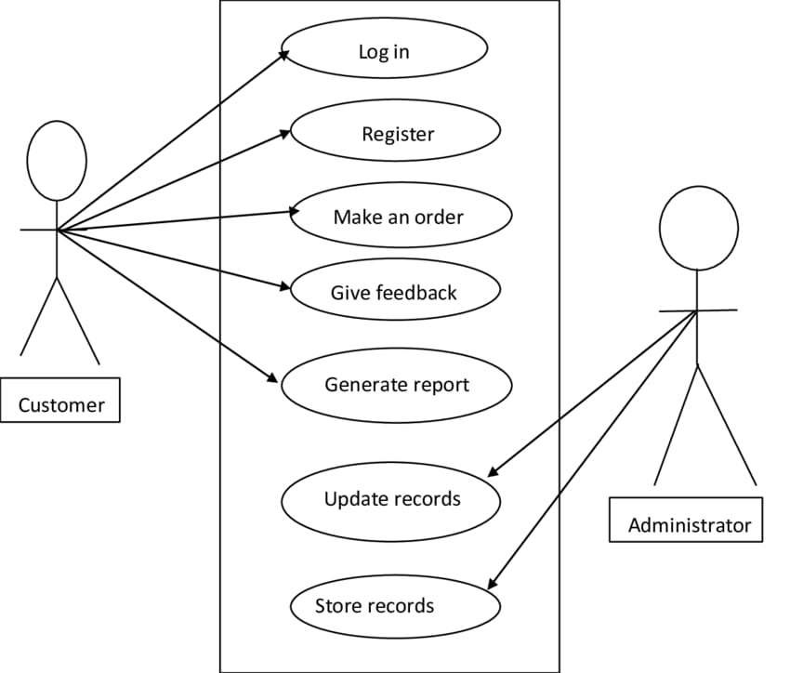

3.2 Data Dictionary
Customer Table

- Customer_ID (Primary Key): Unique identifier for each customer.
- Data Type: Integer.
- Length: 10.
- Name: Customer's full name.
- Data Type: String.
- Length: 50.
- Email: Customer's email address.
- Data Type: String.
- Length: 100.
- Password: Customer's encrypted password.
- Data Type: String.
- Length: 255.
- Address: Customer's mailing address.
- Data Type: String.
- Length: 255.
- Phone: Customer's phone number.
- Data Type: String.
- Length: 20.

Product Table

- Product_ID (Primary Key): Unique identifier for each product.
- Data Type: Integer.
- Length: 10.
- Product_Name: Product's name.
- Data Type: String.
- Length: 100.
- Description: Product's description.
- Data Type: String.
- Length: 255.
- Price: Product's price.
- Data Type: Decimal.
- Length: 10, 2.
- Image_URL: Product's image URL.
- Data Type: String.
- Length: 255.
- Category: Product's category (e.g. necklace, ring, earring).
- Data Type: String.
- Length: 50.
- Subcategory: Product's subcategory (e.g. gold, silver, diamond).
- Data Type: String.
- Length: 50.

Order Table

- Order_ID (Primary Key): Unique identifier for each order.
- Data Type: Integer.
- Length: 10.
- Customer_ID (Foreign Key): Customer who placed the order.
- Data Type: Integer.
- Length: 10.
- Order_Date: Date the order was placed.
- Data Type: Date.
- Length: 10.
- Total_Cost: Total cost of the order.
- Data Type: Decimal.
- Length: 10, 2.
- Status: Status of the order (e.g. pending, shipped, delivered).
- Data Type: String.
- Length: 50.

Payment Table

- Payment_ID (Primary Key): Unique identifier for each payment.
- Data Type: Integer.
- Length: 10.
- Order_ID (Foreign Key): Order that the payment is for.
- Data Type: Integer.
- Length: 10.
- Payment_Method: Method of payment (e.g. credit card, Meezan Bank).
- Data Type: String.
- Length: 50.
- Payment_Date: Date the payment was made.
- Data Type: Date.
- Length: 10.
- Amount: Amount of the payment.
- Data Type: Decimal.
- Length: 10, 2.

Shipping Table

- Shipping_ID (Primary Key): Unique identifier for each shipping.

Customer Table

- Customer_ID (Primary Key): Unique identifier for each customer.
- Data Type: Integer.
- Length: 10.
- Name: Customer's full name.
- Data Type: String.
- Length: 50.
- Email: Customer's email address.
- Data Type: String.
- Length: 100.
- Password: Customer's encrypted password.
- Data Type: String.
- Length: 255.
- Address: Customer's mailing address.
- Data Type: String.
- Length: 255.
- Phone: Customer's phone number.
- Data Type: String.
- Length: 20.

Product Table

- Product_ID (Primary Key): Unique identifier for each product.
- Data Type: Integer.
- Length: 10.
- Product_Name: Product's name.
- Data Type: String.
- Length: 100.
- Description: Product's description.
- Data Type: String.
- Length: 255.
- Price: Product's price.
- Data Type: Decimal.
- Length: 10, 2.
- Image_URL: Product's image URL.
- Data Type: String.
- Length: 255.
- Category: Product's category (e.g. necklace, ring, earring).
- Data Type: String.
- Length: 50.
- Subcategory: Product's subcategory (e.g. gold, silver, diamond).
- Data Type: String.
- Length: 50.

Order Table

- Order_ID (Primary Key): Unique identifier for each order.
- Data Type: Integer.
- Length: 10.
- Customer_ID (Foreign Key): Customer who placed the order.
- Data Type: Integer.
- Length: 10.
- Order_Date: Date the order was placed.
- Data Type: Date.
- Length: 10.
- Total_Cost: Total cost of the order.
- Data Type: Decimal.
- Length: 10, 2.
- Status: Status of the order (e.g. pending, shipped, delivered).
- Data Type: String.
- Length: 50.

Payment Table

- Payment_ID (Primary Key): Unique identifier for each payment.
- Data Type: Integer.
- Length: 10.
- Order_ID (Foreign Key): Order that the payment is for.
- Data Type: Integer.
- Length: 10.
- Payment_Method: Method of payment (e.g. credit card, Meezan Bank).
- Data Type: String.
- Length: 50.
- Payment_Date: Date the payment was made.
- Data Type: Date.
- Length: 10.
- Amount: Amount of the payment.
- Data Type: Decimal.
- Length: 10, 2.

Shipping Table

- Shipping_ID (Primary Key): Unique identifier for each shipping.
- Data Type: Integer.
- Length: 10.
- Order_ID (Foreign Key): Order that the shipping is for.
- Data Type: Integer.
- Length: 10.
- Shipping_Address: Address that the order was shipped to.
- Data Type: String.
- Length: 255.
- Shipping_Method: Method of shipping (e.g. USPS, UPS).
- Data Type: String.
- Length: 50.
- Shipping_Date: Date the order was shipped.
- Data Type: Date.
- Length: 10.
- Tracking_Number: Tracking number for the shipment.
- Data Type: String.
- Length: 50.
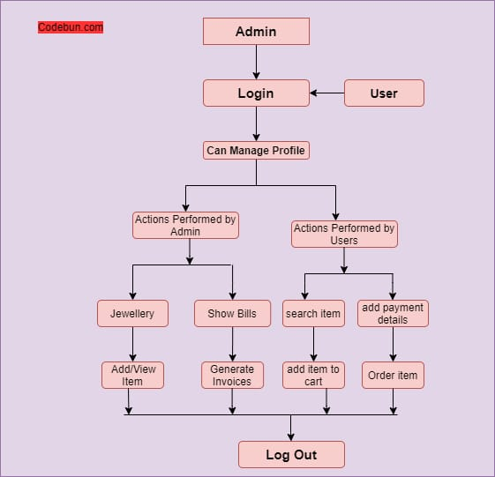

4. Front-end / User Interface Design

4.1 Overview of User Interface
Clean and modern design Easy navigation to different product categories High-quality product images with zoom functionality Detailed product descriptions and specifications Customer reviews and ratings Clear call-to-action buttons for adding to cart or wishlist Simple and secure payment process Option to create an account or checkout as guest Fully responsive and works well on mobile devices Provides a good user experience overall.

4.2 Screen Images
Home Page: Header, hero image, featured products Product Page: Product image, description, reviews, add to cart Shopping Cart: Cart contents, subtotal, apply promo code Checkout Process: Billing/shipping address, payment method, order review.
User Account: Order history, account info, saved payment/shipping.

4.3 Screen Objects and Actions
1. Header - Click.
2. Search Bar - Type and Enter.
3. Product Image - Click.
4. Add to Cart Button - Click.
5. Shopping Cart Icon - Click.
6. Checkout Button - Click.
7. Payment Method Selection - Select.
8. Order Review - Review and Confirm.

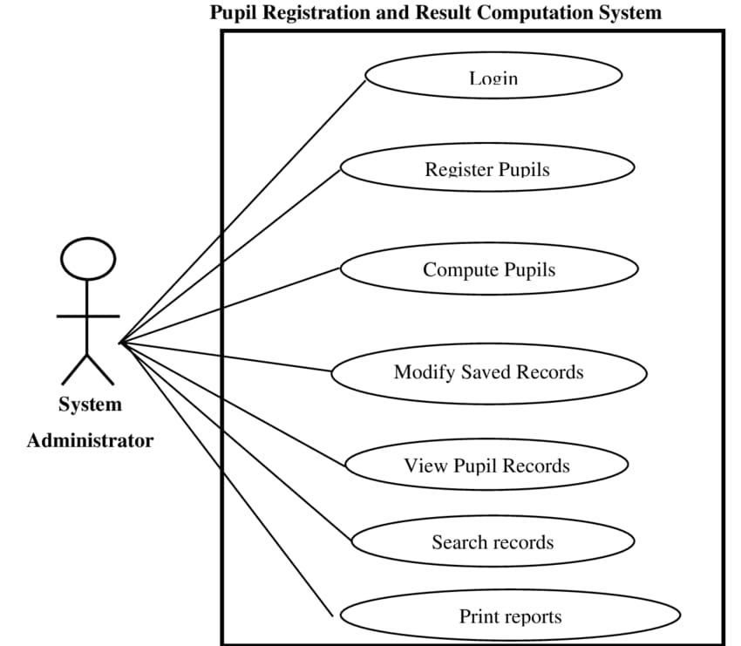

5. System Architecture

5.1 Architectural Design
- Presentation Layer: Web Server, Web Application, Mobile App.
- Application Layer: E-commerce Platform, Order Management System, CRM System.
- Data Access Layer: Database Management System, Data Storage.
- Infrastructure Layer: Server Hosting, Network Infrastructure, Security Measures.

5.2 Decomposition Description
- Web Server, Web Application, Mobile App, E-commerce Platform, Database Management System.
- Payment Gateway, Logistics Integration, Customer Support, Analytics, Security Audits, Data Backup, Scalability, Compliance.

5.3 Design Rationale
- Designed to provide a user-friendly and secure online shopping experience for Pakistani customers.
- Simple navigation, prominent product display, secure payment processing, and fast checkout process.

6. Component Design/System Architecture
R (Reusable)

- Header component.
- Footer component.
- Navigation menu component.
- Product card component.
- Button component.

T (Testable)

- Unit tests for each component.
- Integration tests for component interactions.
- End-to-end tests for user workflows.

R (Reconfigurable)

- Components can be easily customized with different props and styles.
- Components can be reused across different pages and features.

